AI BASED PERSONAL FINANCE MANAGER
Scope and Limitations
Department of Computer Science and Engineering, TKR College of Engineering & Technology
Batch C11 (CSE-C) · Academic year [ACADEMIC YEAR]
Table 1: Project team
S.No. | Student name | Roll number
1 | Mekala Kalyan | 23K91A05F0
2 | Rajanala Sai Hemanth | 23K91A05K3
3 | Middala Surya Teja Reddy | 23K91A05F2
4 | Manga Akash | 23K91A05E5

Project guide: N Padmavathi
Chapter and section numbers quoted in the text (for example Chapter 8 or Section 6.2) refer to the full project report, 17.Final Document. Figures and tables in this document are numbered from 1.

1. SCOPE

1.1 In scope
The project covers the personal finance tasks of one person who records or imports their own transactions. The following were designed, built and tested.
• Accounts and security. Sign-up and log-in with username or e-mail, password rules (eight characters or more with upper case, lower case, digit and special character), bcrypt hashing, signed bearer tokens with a seven-day expiry and per-user data scoping on every table.
• Transactions. Add, edit, delete, search, filter and sort; custom categories; payment method and notes; CSV or Excel import with a preview and row-level warnings.
• Machine learning. Automatic category labelling with learning from corrections; a next-month expense forecast, per-category forecasts and a budget-overrun check; a six-component health score.
• Planning. Monthly category budgets with alerts at 75, 90 and 100 percent; savings goals with progress and required monthly saving; a manual investment portfolio with six asset types and an optional live price refresh.
• Assistant and reports. A rule-routed assistant over the user's data with an optional language-model layer; rule-based insights; PDF, Excel and CSV reports; in-app notifications.
• Interface. A landing page, sign-up and log-in, and ten application pages (dashboard, transactions, analytics, budgets, goals, investments, assistant, reports, notifications, profile) in dark and light themes.

1.2 Out of scope
• Anomaly detection, a reinforcement-learning budget recommender and deep models (BERT, LSTM), which the base paper uses and which were not built.
• Loan and debt tracking, amortisation and prepayment planning, named in the abstract.
• Scheduled jobs such as periodic digest e-mails; alerts are raised when the dashboard or notification list is read, not on a timer.
• Bank-API, SMS or account-aggregator integration; multiple linked accounts; multi-currency conversion.
• Native mobile applications, multi-user households, tax filing and any regulated financial advice.

2. ASSUMPTIONS
The results and the design rest on the following assumptions.
• Each person uses one account and records amounts in a single currency (Indian rupees by default).
• Transaction descriptions are short English phrases with Indian merchant or payment-network wording, like the seed list.
• The user enters or imports income and expense records honestly and reasonably completely; the health score and forecast are only as good as the records.
• Monthly totals are a useful unit for the forecast, and at least three months of history exist before a forecast is requested.
• The application runs on one machine with a local SQLite file and a trusted local network; the default token secret is replaced through the environment before any shared use.
• All demonstration data are fictional: the demo account and the 34-row sample file contain no real personal data.

3. LIMITATIONS
The limitations below were found by measuring the system or by reading the code, and each is stated with the evidence.
• Unseen merchants are silently mislabelled. On the 66 tier-C descriptions the categoriser scores 18.2 percent. 48 of its 56 errors are predicted as Transport, because text with no known word gives a zero feature vector and the decision then comes from the intercepts. The app applies no confidence threshold and the model never answers Other.
• The seed list is tiny. Fifty-one descriptions (three to six per class) are the whole training set; leave-one-out accuracy on them is 11.8 percent. The 100 percent score on the bundled 34-row sample is optimistic because its wording overlaps the seed list.
• Corrections help repeat merchants only. One correction lifts the same merchant, narrated three other ways, from 18.2 to 100 percent, but forty-eight corrections of other merchants raise tier-C accuracy only from 18.2 to 21.5 percent.
• The probe set is not an independent benchmark. The team wrote the 198 descriptions before scoring and never trained on them, but the same people wrote the seed list.
• The forecast is a straight line. On the demo account's three backtest points it has a MAPE of 28.4 percent against 21.4 percent for the mean of all months, and in simulation it only beats a plain average from about seven months of history. The three-month minimum is too low for this method.
• Health-score weights are chosen, not fitted. Savings rate and expense ratio together carry half of the score and are strongly correlated; no user study checked that the score matches how people judge their finances.
• The assistant is a rule router. It handled 14 of 20 answerable test questions; questions about groceries, the biggest expense or running out of money fell to the fixed help text. "Am I overspending on shopping?" is answered with the Shopping total, not a budget comparison.
• Import is slow per row. Each row is committed in its own database session, giving 35.2 rows per second.
• Alerts and dates. Budget alerts are de-duplicated by message text only, so a budget that crosses the same threshold in a later month raises no new alert; the month end is written as the 31st, which works for SQLite date strings but not for strict databases.
• Weak token design. Bearer tokens are home-made HMAC-SHA256 values without refresh or revocation, the default secret finjarvis-dev-secret is used if APP_SECRET_KEY is not set, and CORS allows only localhost:5411.
• Single-user storage. One SQLite file, no migrations, no backups; passlib needs bcrypt==4.0.1 because bcrypt 5 breaks hashing.
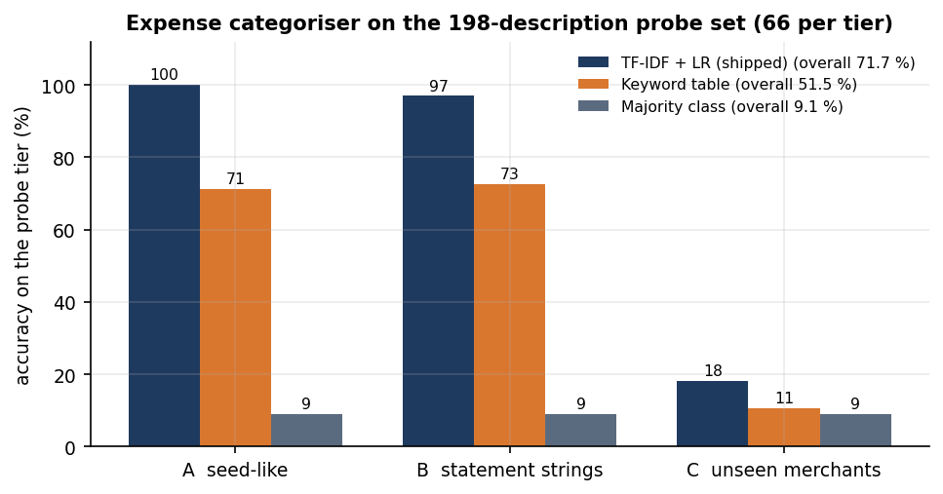
Figure 1: Accuracy of the shipped categoriser, the keyword table and the majority class on the three probe tiers.
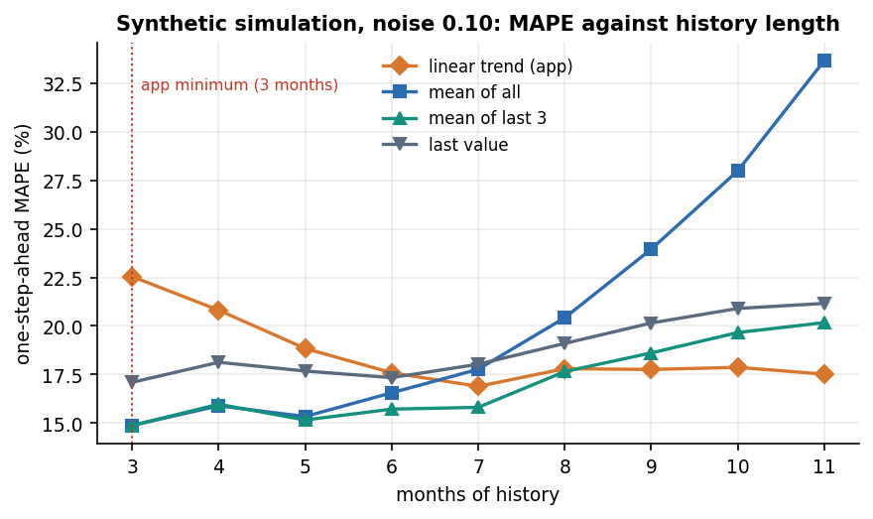
Figure 2: Simulated one-step-ahead error against months of history: the linear trend overtakes a plain average only after several months.
Three figures show the limitations that matter most for reading the numbers. The first shows the confusion matrix of the categoriser on the probe set: the Transport column collects the errors on descriptions the model has never seen. The second shows how little a user's corrections help with new merchants, against the complete fix for a repeat merchant. The third shows the sensitivity of the health score to its inputs, including the point at which the savings-rate component saturates.
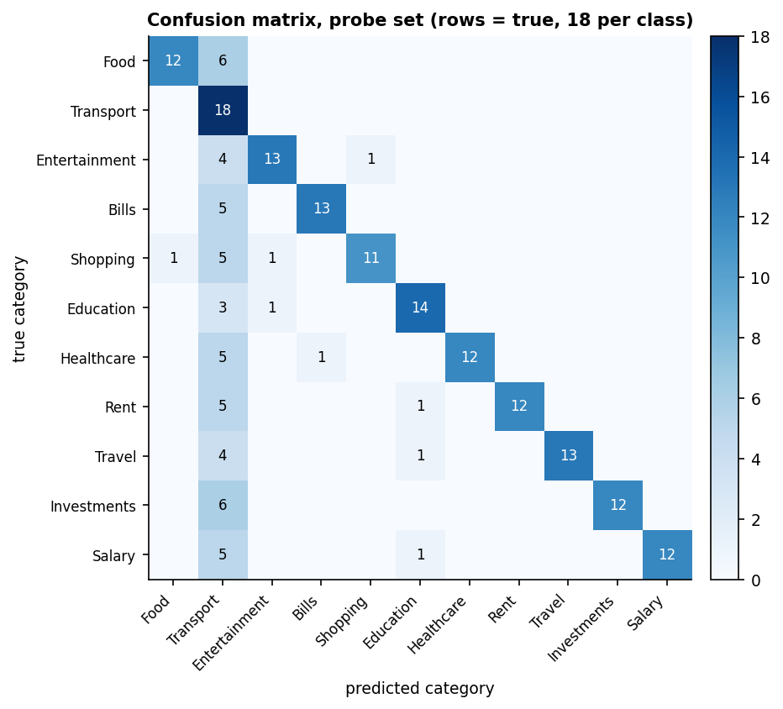
Figure 3: Confusion matrix of the shipped categoriser on the 198-description probe set (rows are true categories).
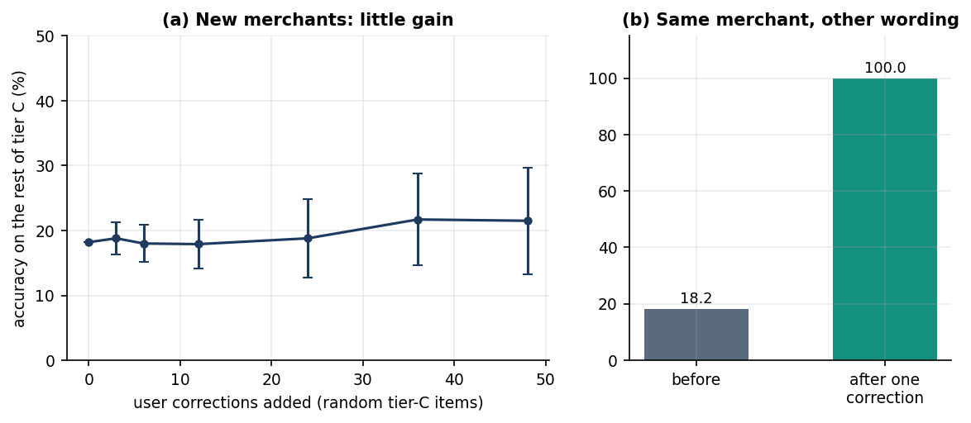
Figure 4: Learning from corrections: tier-C accuracy against the number of corrections, and the repeat-merchant test.
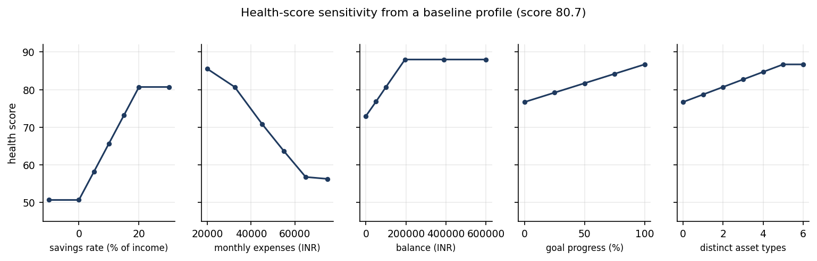
Figure 5: Health-score sensitivity to savings rate, expenses, balance, goal progress and asset types.

4. WHAT WAS NOT MEASURED
The following were not measured, and no number for them appears in any document of this submission.
• The optional language-model layer (AI_API_KEY): no measurement ran with a key, so its answers, cost and failure behaviour are unknown.
• The live price refresh through yfinance, which needs internet access.
• Concurrency and load: all latency figures are single-user, single-process, warm-server values on 127.0.0.1.
• Mobile browsers, accessibility and cross-browser behaviour; screens were captured with Playwright in Chromium and inspected by eye, with no automated UI tests.
• Security testing beyond the 49-check smoke test: no penetration test or dependency audit.
• Real personal data: every figure comes from fictional demo data, the team's probe set or seeded simulation.
• Any comparison with a commercial finance application, and any user study of whether the advice changes behaviour.
• Anomaly detection, reinforcement-learning budgeting and savings forecasting, which were not built, so no accuracy exists to report.

